
Form 2
Capstone Design Proposal
Title : Integrated Operational Management System for C3MR: Web Admin Portal & Telegram Mini App Ecosystem

GROUP MEMBER:
No. | Student Name | Student ID | Study Program
1. | Auza Syamil Nabawi | 001202300150 | Informatics
2. | Rashad Abdul Faqih | 001202300149 | Informatics
3. | Atthariqul Hazam Albanna | 012202300122 | Information System

Advisor : Dr. Adhi Setyo Santoso, ST.MBA.

Submitted for
Capstone Design Project
Faculty of Computer Science
President University
2026

TABLE OF CONTENT
STATEMENT OF ORIGINALITY 3
TITLE 4
PART 2: SYSTEM ANALYSIS 5
1. EXISTING AND PROPOSED SYSTEM 5
Existing Business Process 5
Proposed Business Process 6
2. GLOBAL DESCRIPTION OF THE PRODUCT 7
Main Functionality 7
User Characteristics 7
Constraints 7
Product Development Environment 7
Product Operational Environment 7
3. REQUIREMENT ANALYSIS 8
Interface 8
Functional Description 8
Functional Requirement 10
Non-Functional Requirement 11
4. ALTERNATIVE SOLUTION 12
REFERENCES 13

STATEMENT OF ORIGINALITY
In my capacity as an active student at President University and as the author of the Capstone Design Project stated below:
Name : 1. Auza Syamil Nabawi – 001202300150
2. Rashad Abdul Faqih – 001202300149
3. Atthariqul Hazam Albanna – 012202300122
Faculty : Computer Science
I hereby declare that my Capstone Design Project entitled “Integrated Operational Monitoring System for Telkomsel C3MR Data: A Secure Hybrid Approach Using Web Dashboard and Telegram Bot” is to the best of my knowledge and belief, an original piece of work based on sound academic principles. If there is any plagiarism detected in this final project, I am willing to be personally responsible for the consequences of these acts of plagiarism and will accept the sanctions against these acts in accordance with the rules and policies of President University.
I also declare that this work, either in whole or in part, has not been submitted to another university to obtain a degree.

Cikarang, 2026
Signer 1 | Signer 2 | Signer 3
 | 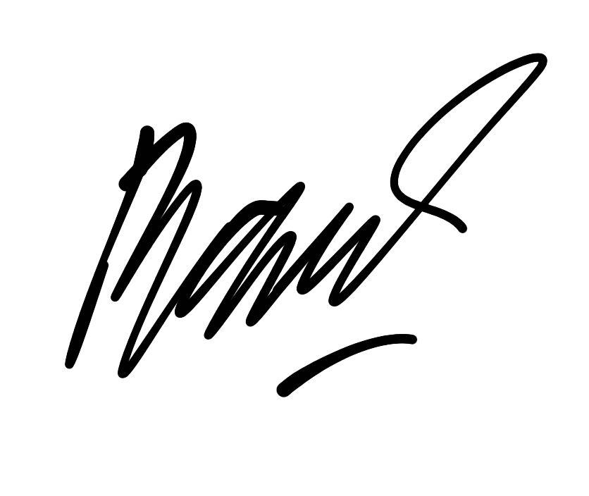 | 
Auza Syamil Nabawi  001202300150 | Rashad Abdul Faqih  001202300149 | Atthariqul Hazam Albanna  012202300122

TITLE

Approved:

Dr.Adhi Setyo Santoso, ST.MBA.  Capstone Advisor | Rosalina, M.Kom.  Program Head of Informatics Study Program

Prof. Dr. Ir. Wiranto Herry Utomo, M.Kom.
Dean of Faculty of Computer Science

PART 2: SYSTEM ANALYSIS

1. EXISTING AND PROPOSED SYSTEM

Existing Business Process
The operational efficiency of Telkomsel's Collection Team (C3MR) is currently hampered by its reliance on manual workflows, which cause bottlenecks in the data processing cycle.
- Target Extraction & Distribution: Administrative staff manually extract target data using spreadsheets (Excel) and distribute it via instant messaging applications.
- Field Execution & Reporting: Call to Bar (CTB) officers are not supported by adequate digital reporting devices. They are forced to report their field visit results manually via text in chat groups or attempt to access heavy spreadsheet documents via their mobile devices.
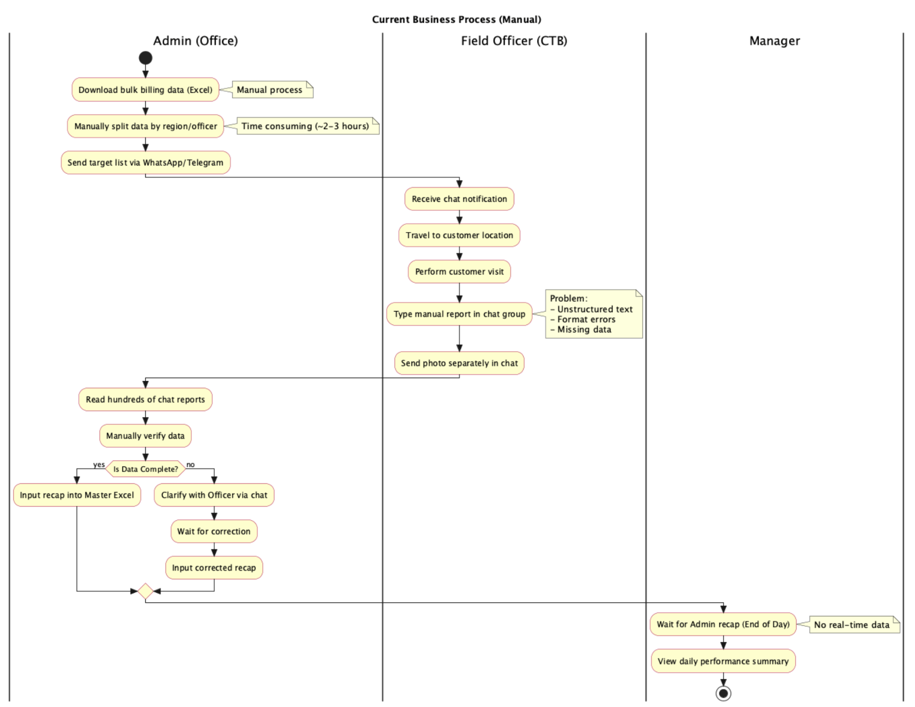
- Manual Recapitulation: This system mismatch results in double handling for administrative staff, who must manually and repeatedly input target distributions and recapitulate daily reports, creating redundant work that significantly slows the team's productivity.

Proposed Business Process
The proposed system digitizes the input sources at both ends, eliminating double-handling and establishing a real-time data pipeline.
- Target Distribution: The Admin logs into the Web Portal and uploads targets directly into the system. The system automatically assigns these tasks to the respective CTB officers.
- Field Execution: Officers access a lightweight Telegram Mini App, which runs on the cloud within their existing Telegram app, to view their assigned tasks.
- Reporting: Officers input results directly into the Mini App using structured input forms (e.g., Dropdowns for Status, Photo Uploads). This eliminates the need for manual recaps.
- Monitoring: Managers can request summary data in real-time through the Telegram Summary Bot.
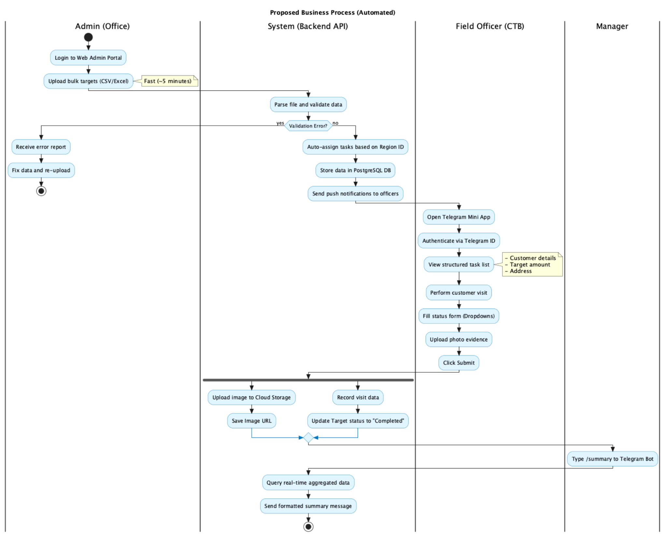

2. GLOBAL DESCRIPTION OF THE PRODUCT

Main Functionality
The product is an integrated digital ecosystem consisting of three primary interfaces:
- Web Admin Portal: A centralized dashboard for "Heavy Input", allowing Admin staff to upload target data, assign tasks, and manage customer records.
- Telegram Mini App: A "Field Input" interface for CTB officers to report results. It provides a fast, familiar interface within Telegram without installing anything new.
- Summary Bot: A read-only monitoring tool providing simple performance recaps for management.

User Characteristics

Constraints
- Platform Dependency: The Mini App module relies on the Telegram Bot API ecosystem to function correctly.
- Network Coverage: Field officers require an active cellular internet connection to submit real-time reports via the Mini App.

Product Development Environment
- Hardware: Laptops/PCs (Minimum Core i5, 8GB RAM) for backend and web development. Android smartphones for Telegram Mini App field testing.
- Software: Python 3.10 (Backend), JavaScript/TypeScript (Frontend), FastAPI, React.js, Telegram Web Apps SDK, Supabase (PostgreSQL), Git, Visual Studio Code.
- Connection: Broadband/WiFi for API development and database hosting access.

Product Operational Environment
- Hardware: Office PCs/Laptops for Admins. Android smartphones for Field Officers.
- Software: Modern Web Browser for the Web Portal. Telegram Messenger Application for the Mini App and Bot.
- Connection: LAN/WiFi for office staff. Cellular Data (4G/5G) for field officers.

3. REQUIREMENT ANALYSIS

Interface
Interface between the product and the user:
- Hardware Interface: PC/Laptop Monitors (Office), Android Smartphone Touchscreens (Field).
- Software Interface: Web Portal GUI (React), Telegram Mini App Webview GUI, Telegram Chat Interface.
- Connection: Internet via HTTPS and WSS (WebSocket Secure) for API requests and Telegram integrations.

Functional Description
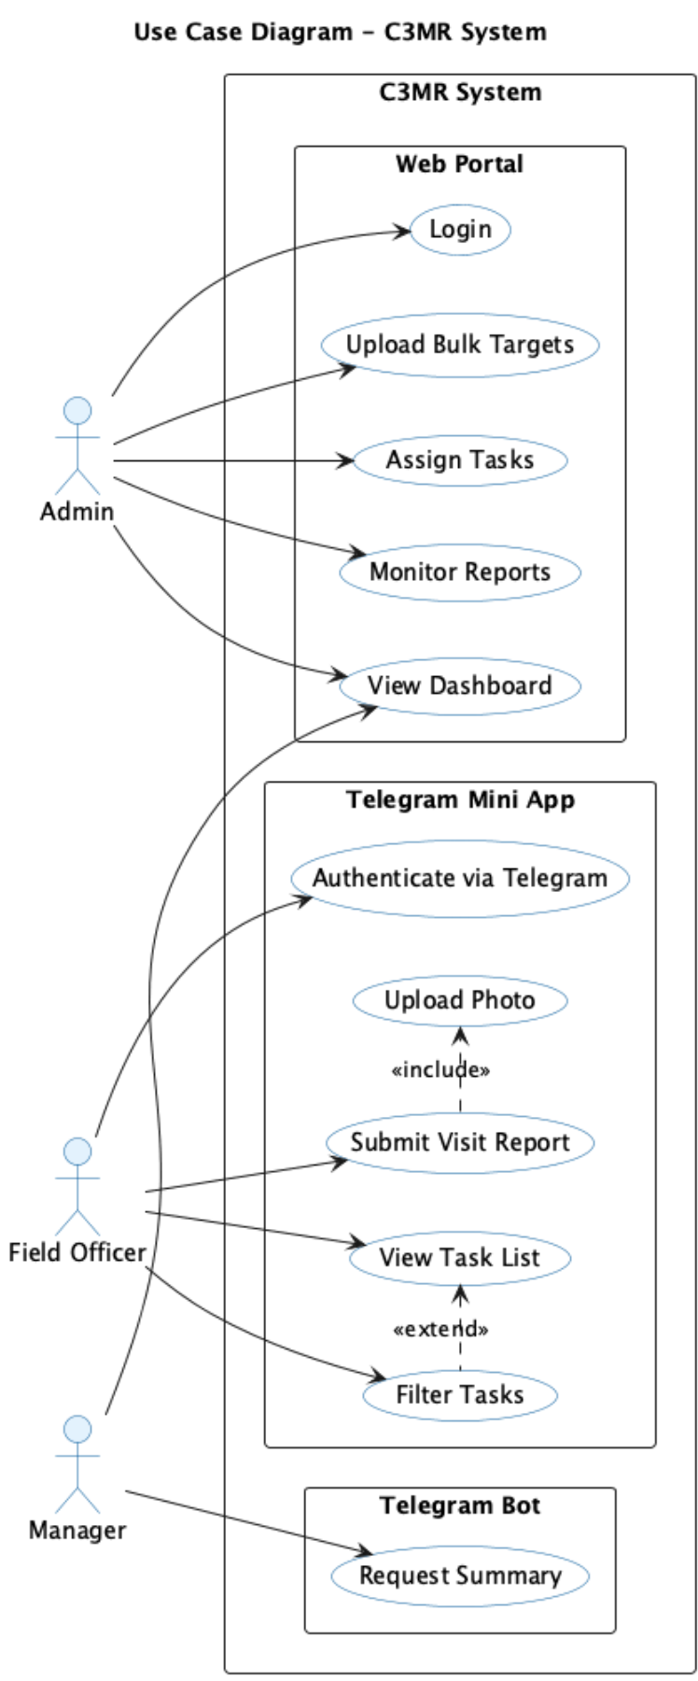
Use-Case Scenarios:
- UC-1: Manage Targets (Admin): Admin accesses the Web Portal to input target data. The system stores the target and assigns it to the specified CTB officer.
- UC-2: View Task List (Officer): The field officer opens the Telegram Mini App. The app fetches and displays the pending customer visits assigned to their specific Telegram ID.
- UC-3: Submit Field Report (Officer): The officer selects a task, fills out a structured form (e.g., payment status), uploads photo evidence, and submits it. The system updates the database in real-time.
- UC-4: Generate Summary (Manager): The manager sends a summary command to the Telegram Bot, which retrieves aggregated daily statistics from the database.

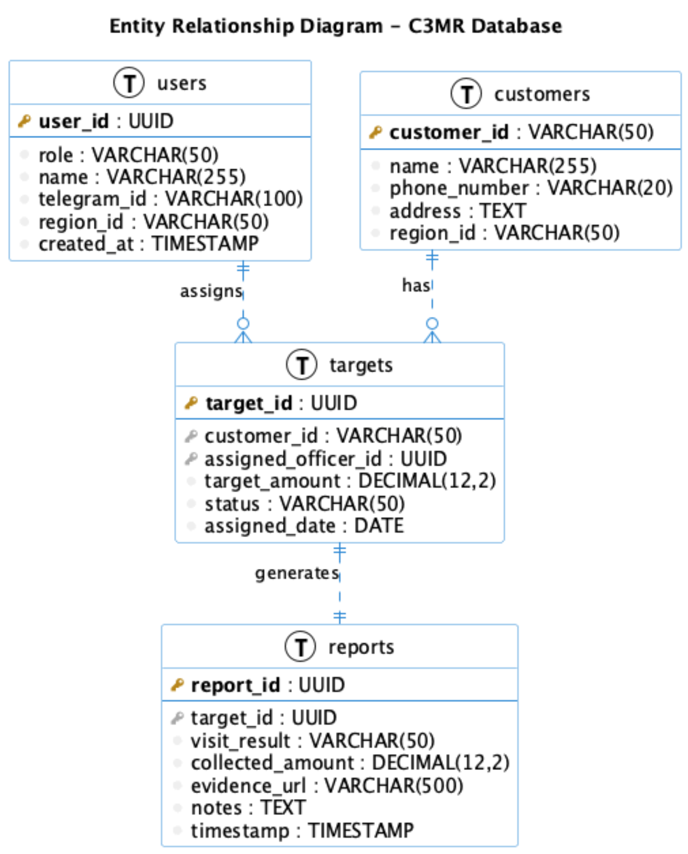

Data Dictionary (Entity tables):
- users Table: user_id (PK), role, name, telegram_id (Unique), region_id.
- customers Table: customer_id (PK), name, phone_number, address, region_id.
- targets Table: target_id (PK), customer_id (FK), assigned_officer_id (FK), status.
- reports Table: report_id (PK), target_id (FK), visit_result, evidence_url, timestamp.
Relations:
- One user has Many targets (1:N).
- One customer has Many targets (1:N).
- One target has One report (1:1).

Functional Requirement
Explain the process of the functional description that is already explained in the use-case diagram above.
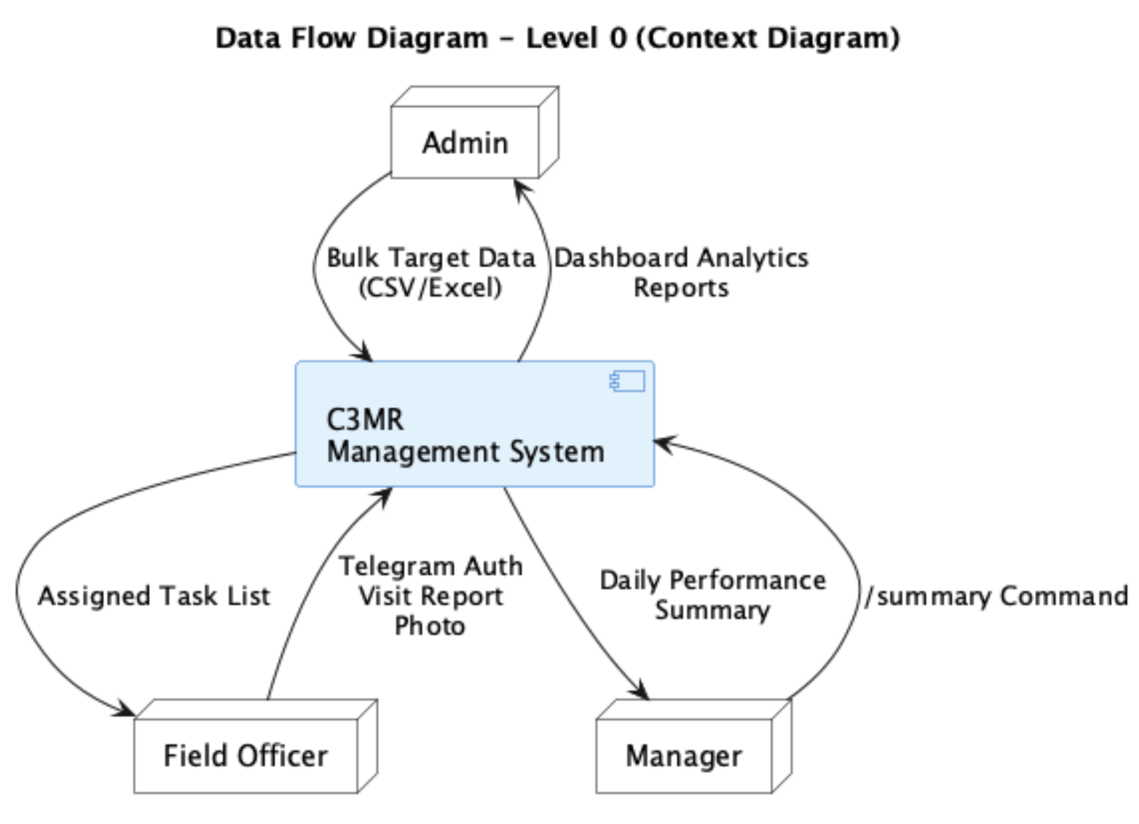
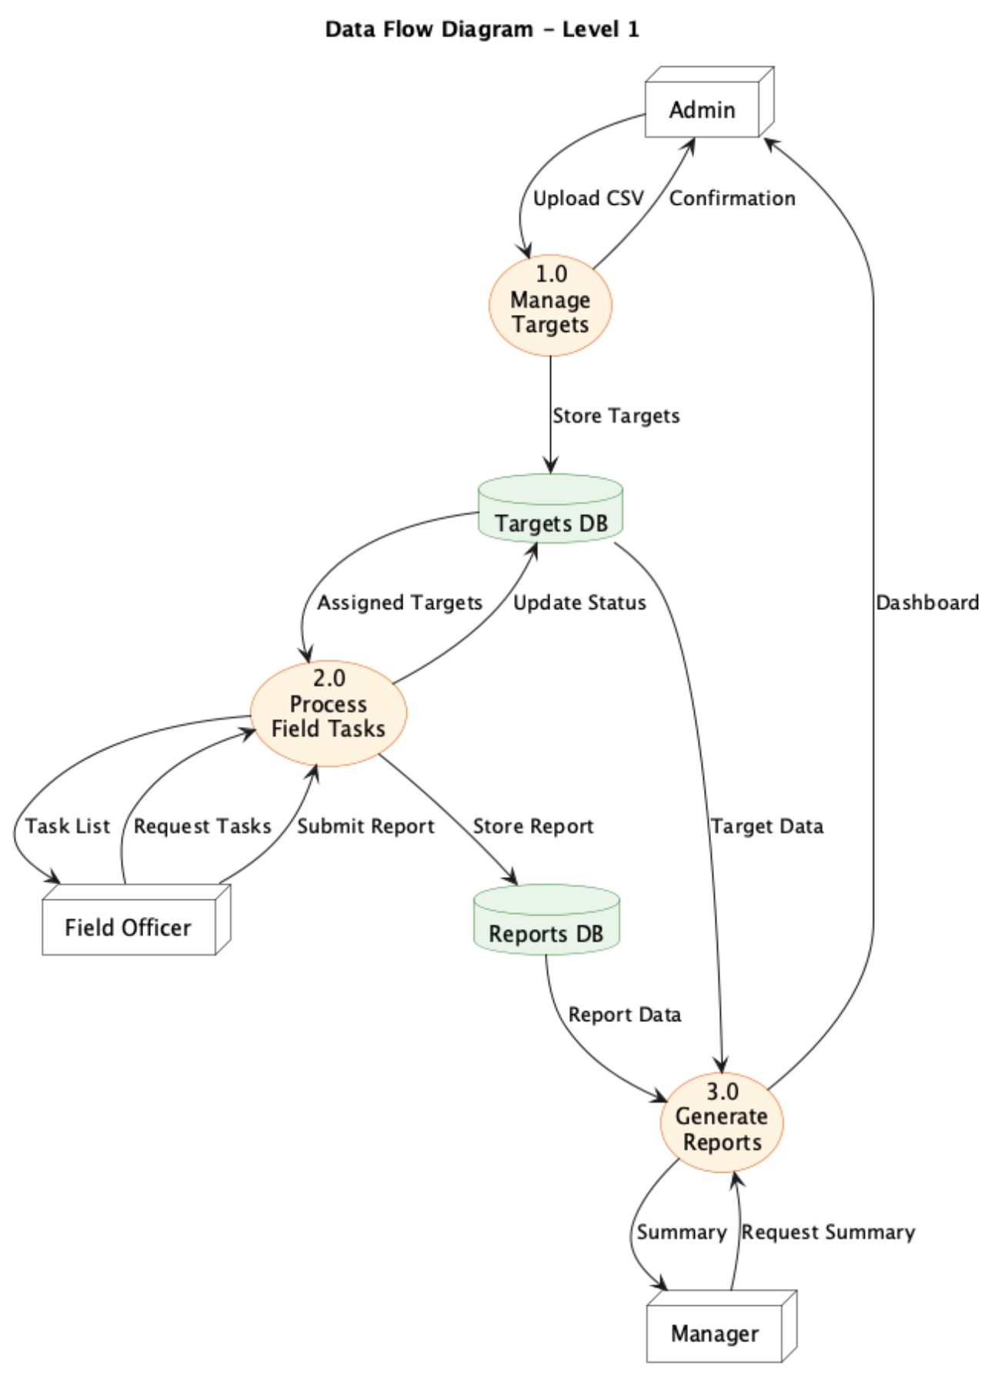
Process Description:
- Data Initialization: The Admin provides target datasets via the Web Portal. The system populates the targets and customers databases.
- Task Retrieval: The Field Officer's Telegram client requests data. The API verifies the user's telegram_id and retrieves the assignment list.
- Report Submission: The Field Officer submits form data and images via the Mini App. The API stores the image in cloud storage, saves the record in the reports table, and updates the targets status.
- Analytics Aggregation: The system continuously aggregates report data to serve Web Dashboard visualizations and Manager Bot requests

Non-Functional Requirement
- Security: The system requires user whitelisting; only registered Telegram IDs can access the Mini App interface.
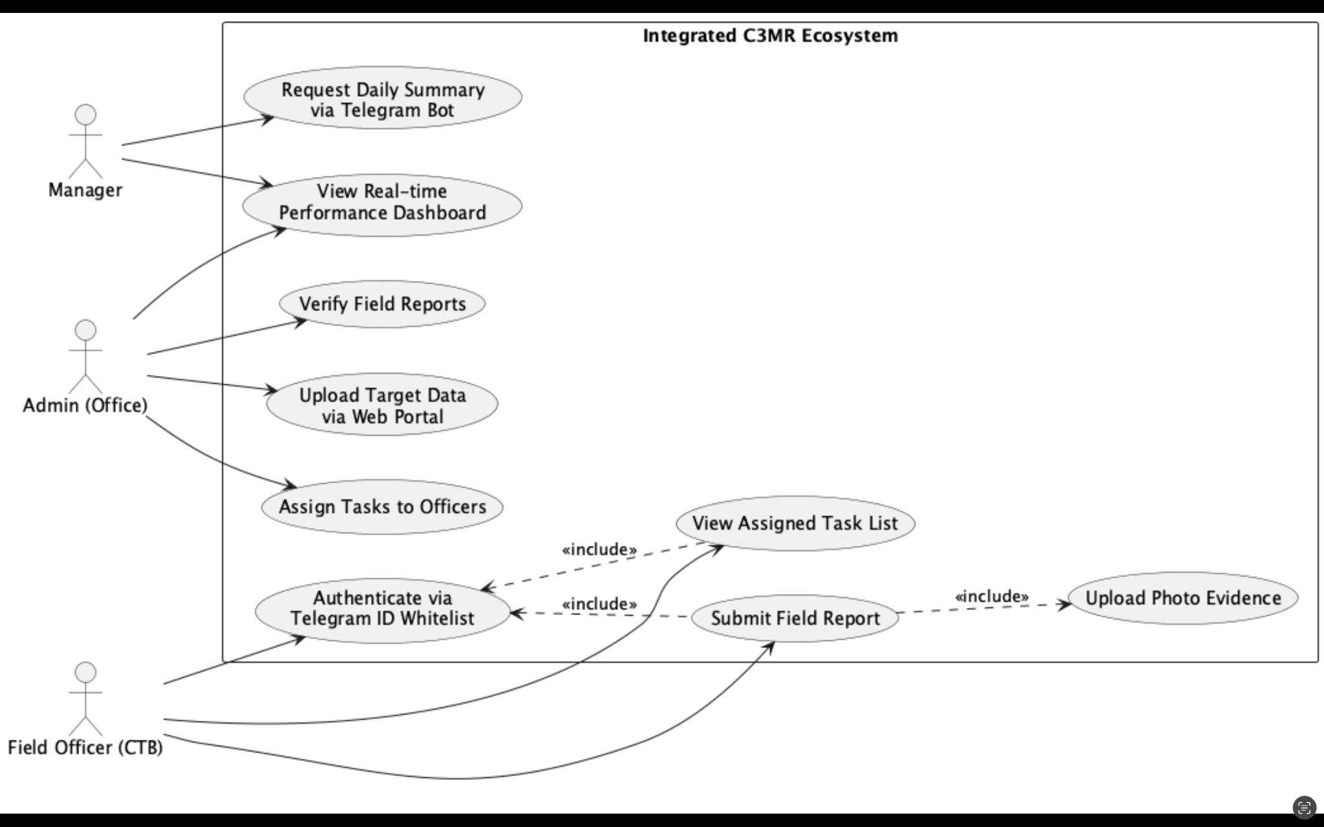
- Data Privacy: Data Masking must be applied to sensitive Personally Identifiable Information (PII) such as customer phone numbers.

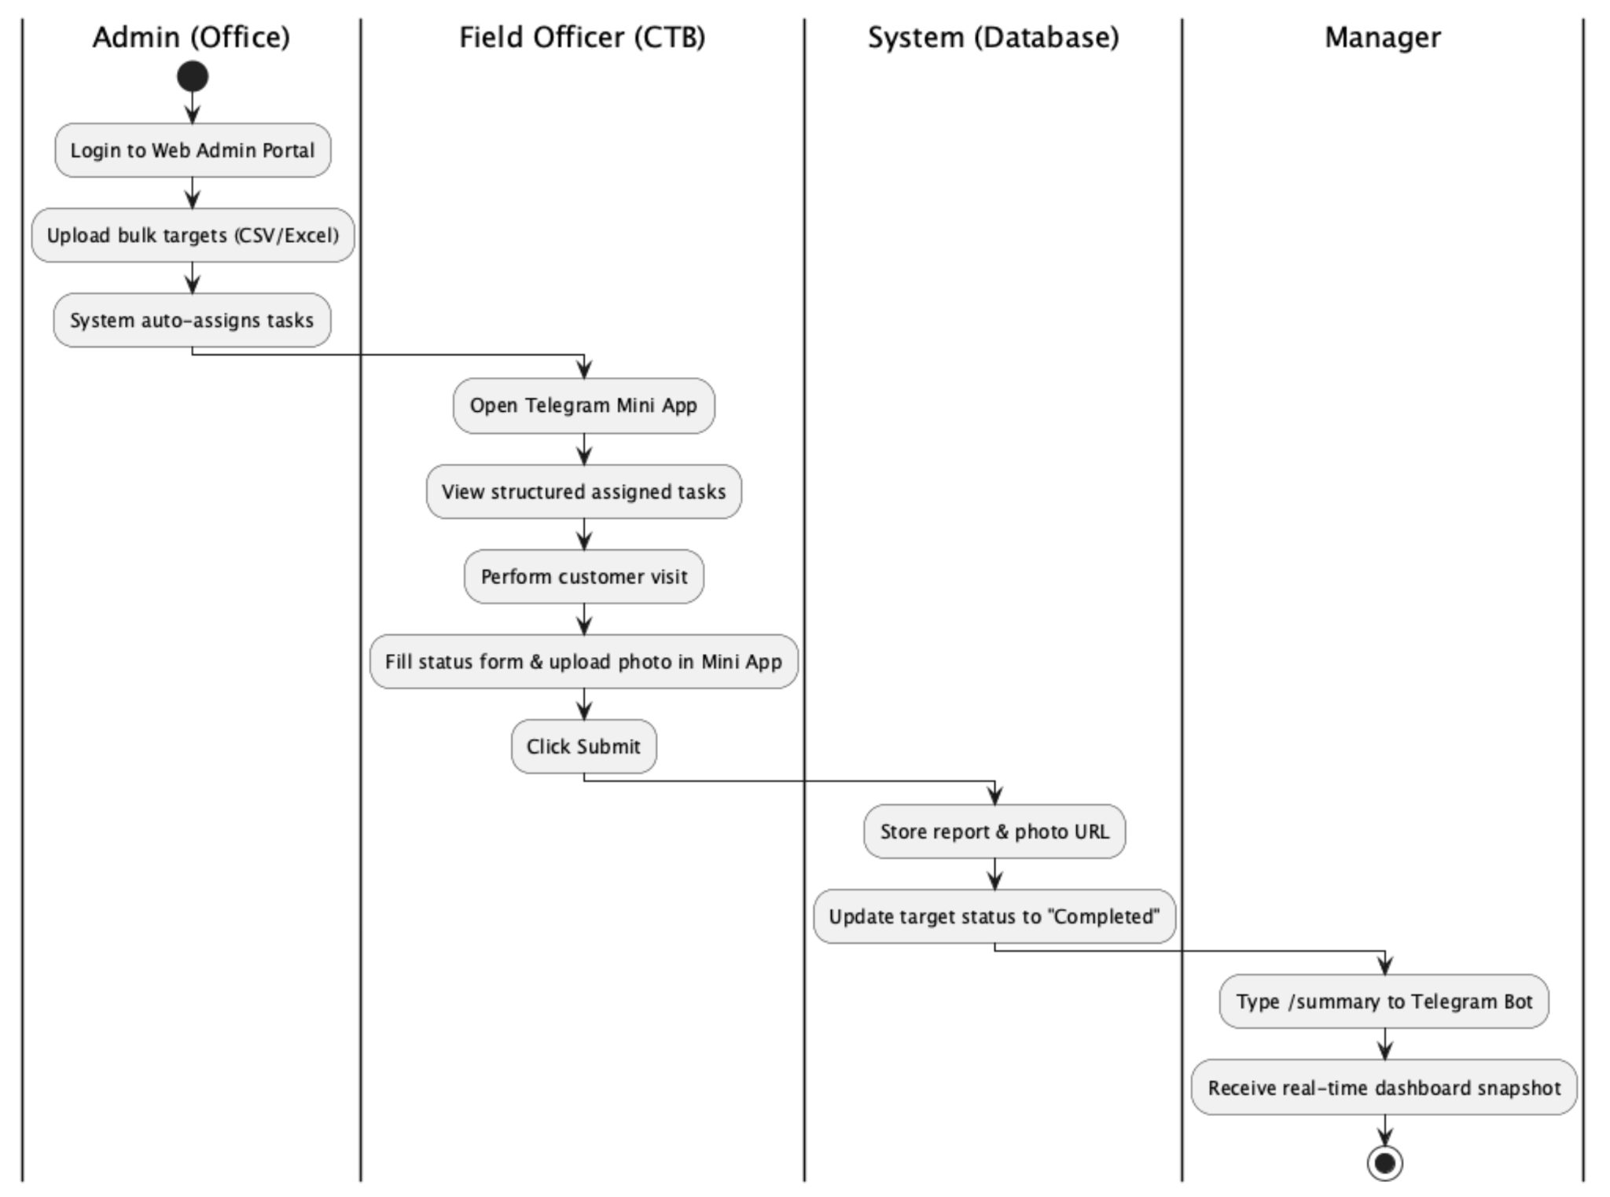

4. ALTERNATIVE SOLUTION
1. Native Android Application (.apk) Developing a dedicated standalone Android application specifically for the field officers (CTB).
- Explanation: This approach offers high performance, offline caching capabilities, and deep integration with Android hardware features. However, it introduces significant friction regarding deployment and maintenance. Field officers possess highly varied Android smartphone specifications. Asking them to manually download, install, and frequently update a corporate .apk file consumes their device storage and often meets high user resistance.
2. Web-Based Only System A responsive website for both Admins and Officers.
- Explanation: This approach utilizes a single codebase. However, officers in the field find it inconvenient to constantly login and logout of a browser. It lacks the immediate "Push Notification" capability of a chat app, which is essential for operational communication.

REFERENCES
- President University Capstone Design Project Guidelines.
- Telegram Bot API & Mini Apps Documentation.
- Supabase Documentation.
- OWASP Top 10 Security Guidelines.

